***“Heaven’s Light is Our Guide”***



**Department of Computer Science & Engineering**

**RAJSHAHI UNIVERSITY OF ENGINEERING & TECHNOLOG**

**Lab Report**

|  |
| --- |
| **Submitted By:**  **Name: Khandoker Sefayet Alam**  **Roll:2003121**  **Department: Computer Science & Engineering**  **Section-C**    **Course code: CSE 3101**  **Course name:** |

|  |
| --- |
| **Submitted To:** |

Query 1.1: Find the name, genre, and IMDB rating of all the movies.  
  
SQL code:

SELECT movie_name,genre,IMDB_Rating

FROM movie as M;  
  
Output:

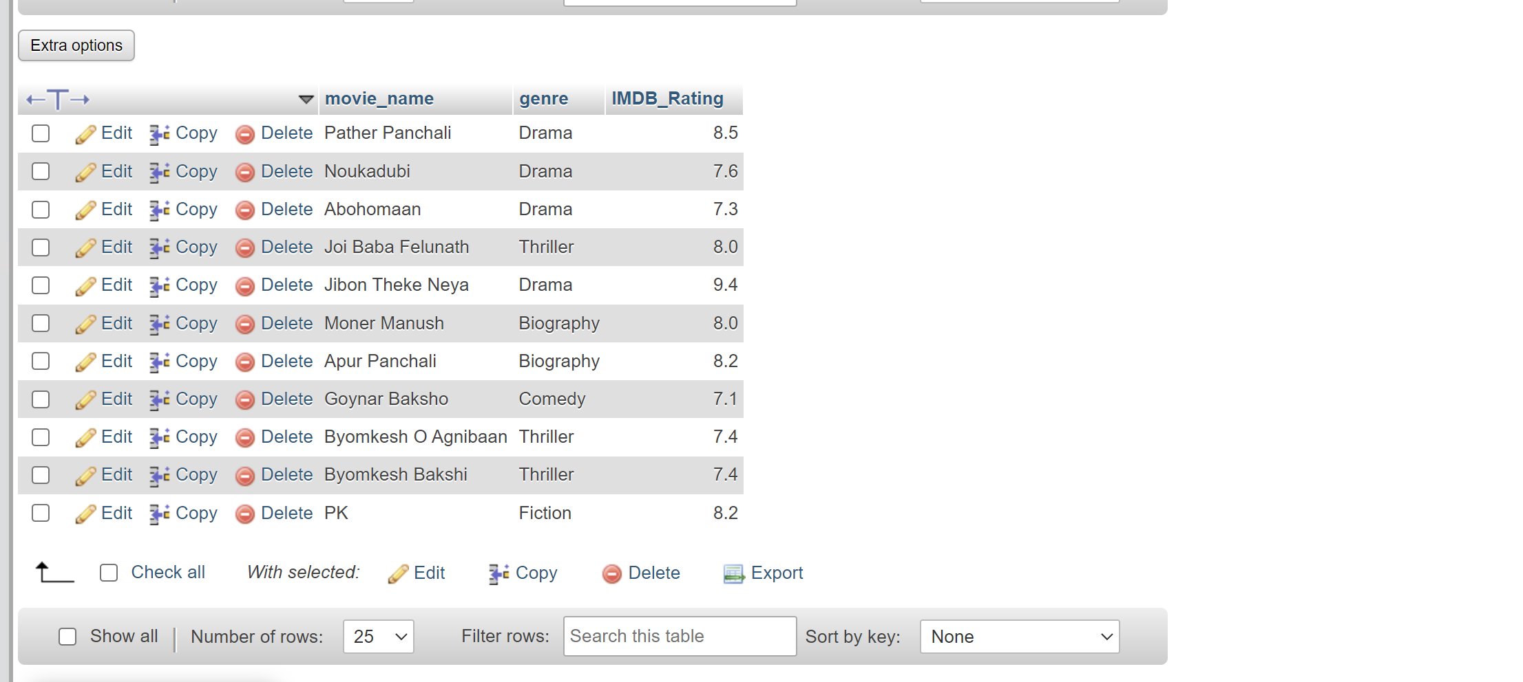

Query 1.2: Display all the distinct movie-genres.

SQL code:

SELECT DISTINCT Genre FROM `movie` ;

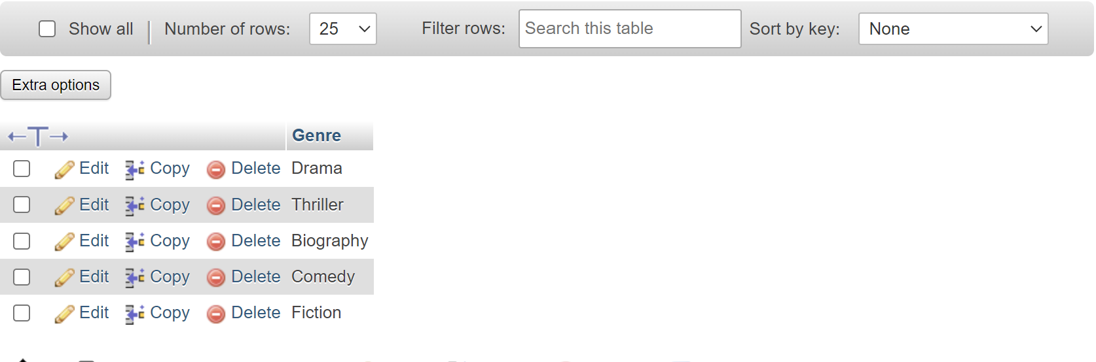

Query-1.3: Find the name and current age of all the actors.

SQL code:

SELECT actor_Name,Year(Now())-Birth_Year as age FROM actor ;  
  
OUTPUT:

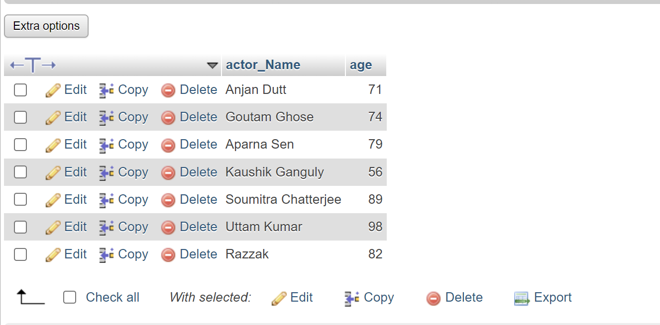

Query 1.4: Find all the movies of the thriller genre with an IMDB rating

greater than or equal to 8.0.  
  
SQL code:

SELECT movie_name,genre FROM movie WHERE genre='Thriller' AND IMDB_Rating>=8.0;  
  
OUTPUT:



Query 1.5: Find the name, release year, IMDB rating, and the name of the

director of all the movies.

SQL code:

SELECT Movie_Name,IMDB_Rating,Director_name FROM movie,director WHERE movie.Director_ID=director.Person_Id ;

OUTPUT:  
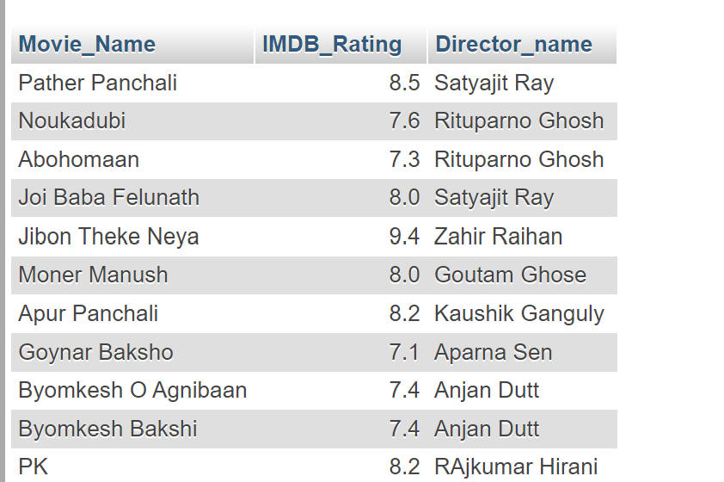

Query 1.6: Find the name and number of awards of those directors whose

name starts with a ‘S’ or a ‘A’.  
  
SQL code:  
  
SELECT Director_name,No_Of_Awards FROM director WHERE director_name LIKE 'A%' OR director_name LIKE 'S%';

OUTPUT:

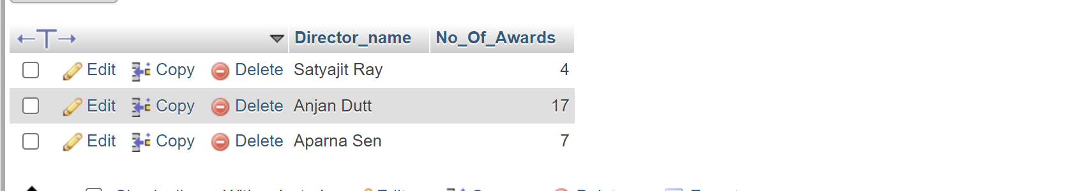

Query 1.7: Find the name and birth year of those directors whose name

contains an ‘a’ as its 2nd last character.  
  
SQL code:

SELECT Director_name,Birth_Year FROM director WHERE director_name LIKE '%a_' ;  
  
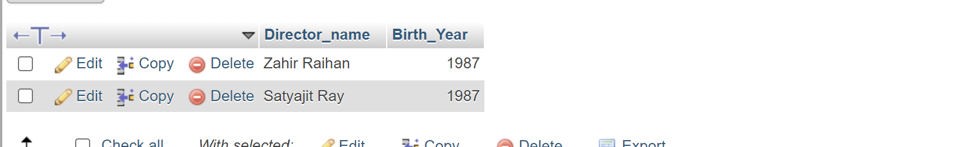

Query 1.8: Find the name, release year, and genre of all the movies which

contain the word ‘Byomkesh’ anywhere in their name.

SQL code:

SELECT Movie_name,year,genre FROM movie WHERE movie_name LIKE '%Byomkesh%' ;

OUTPUT:

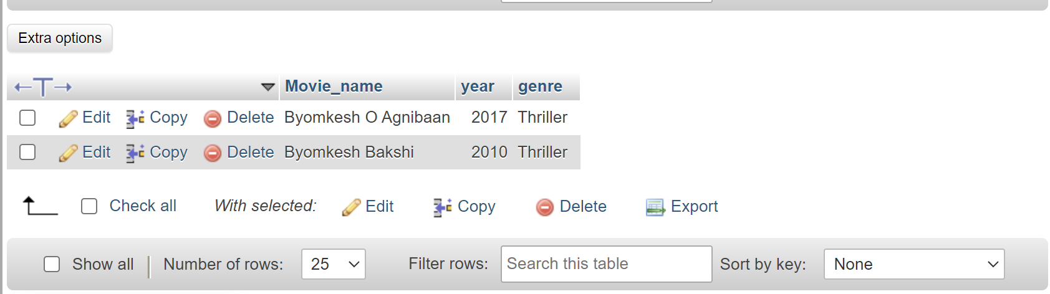

Query 1.9: Find the name and IMDB rating of all the movies whose name

consists of only 2 characters.

SQL code:

SELECT movie_name,IMDB_Rating FROM movie WHERE Movie_Name LIKE '__' ;

OUTPUT:

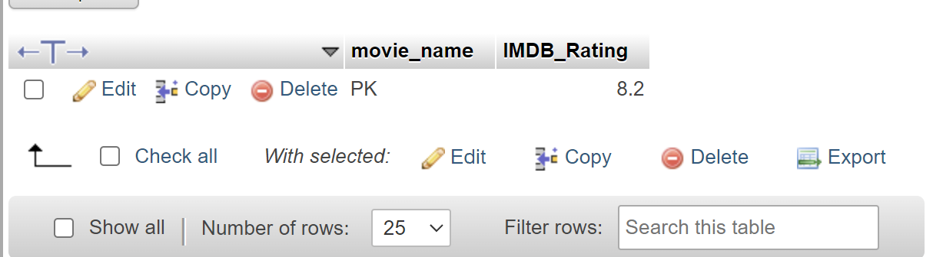

Query 1.10: Find the name and genre of all the movies whose name consists

of at least 3 characters.

SQL code:

SELECT movie_name,genre FROM movie WHERE Movie_Name LIKE '%___%' ;

OUTPUT:

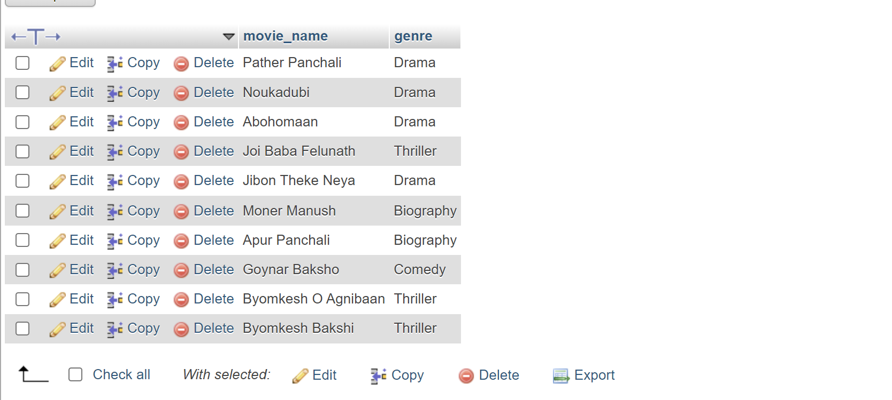

Query 1.Last: Find the name and IMDB rating of all the movies which

contain at most 9 characters in their name.

SQL code:

SELECT movie_name,IMDB_Rating FROM movie WHERE Movie_Name NOT LIKE '%__________%' ;

OUTPUT:

